Experiment Name: Static Routing Configuration in a Multi-Router Network
Objective
The aim of this experiment was to design and configure a multi-router network in Cisco Packet Tracer using static routing. The network consisted of four routers connected in series, with each router serving a local LAN through an individual switch. Eight PCs were distributed across four switches, and each PC was assigned an IP address within its respective subnet. The goal was to ensure full end-to-end connectivity across all subnets using manually configured static routes.
Introduction
Routers make forwarding decisions using routing tables. When routing is configured statically, all routes are manually added by the network administrator. Static routing offers full control over routing paths, predictable behavior, and low overhead, making it ideal for smaller, controlled networks. In this experiment, static routing was used to interconnect four LANs through four routers in a linear topology, ensuring communication between all end devices.
Required Devices
- Four Cisco 1841 routers
- Four Cisco 2960 switches
- Eight PCs
- Straight-through cables for LAN links
- Serial DTE/DCE cables for router-to-router links
Procedure
Step 1: Placing all required devices
All routers, switches, and PCs were dragged into the Cisco Packet Tracer workspace. Each LAN contained one switch and two PCs, and each switch connected to one router.
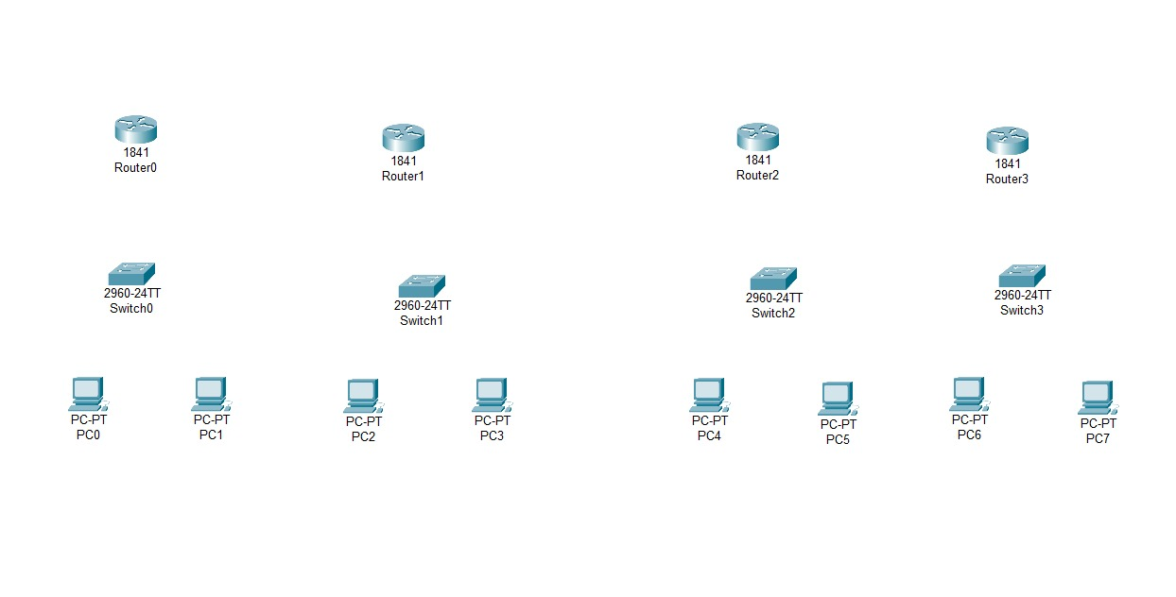
Figure 5.1: Placing all the devices in the workstation
Step 2: Making the physical connections
Straight-through cables were used to connect PCs to switches and switches to routers. Since back-to-back router connections require serial interfaces, Serial DTE cables were used for connecting The routers.
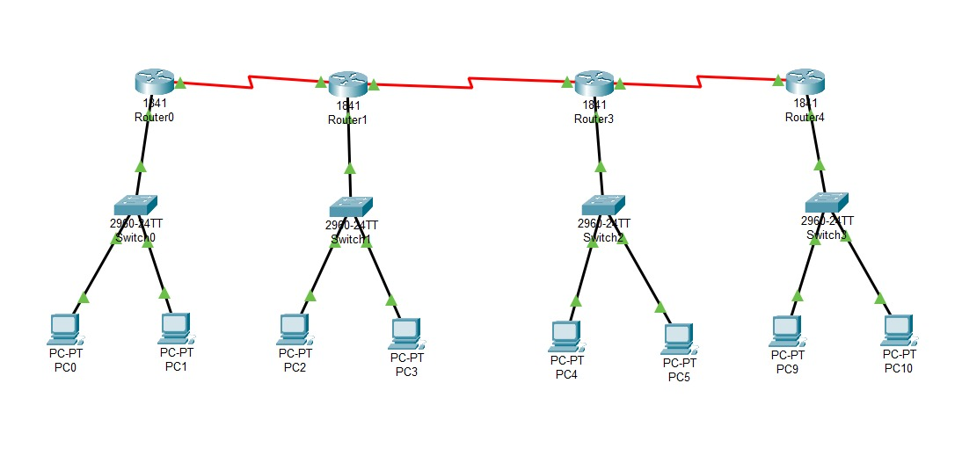
Figure 5.2: Connecting the devices

Step 3: Assigning IP addresses to the PCs
Each PC was assigned an IP address and default gateway according to its LAN. The gateway corresponds to the FastEthernet0/0 interface of the connected router.
PC IP Address - Gateway
PC0 192.168.1.2 - 192.168.1.1
PC1 192.168.1.3 - 192.168.1.1
PC2 192.168.2.2 - 192.168.2.1
PC3 192.168.2.3 - 192.168.2.1
PC4 192.168.3.2 - 192.168.3.1
PC5 192.168.3.3 - 192.168.3.1
PC6 192.168.4.2 - 192.168.4.1
PC7 192.168.4.3 - 192.168.4.1
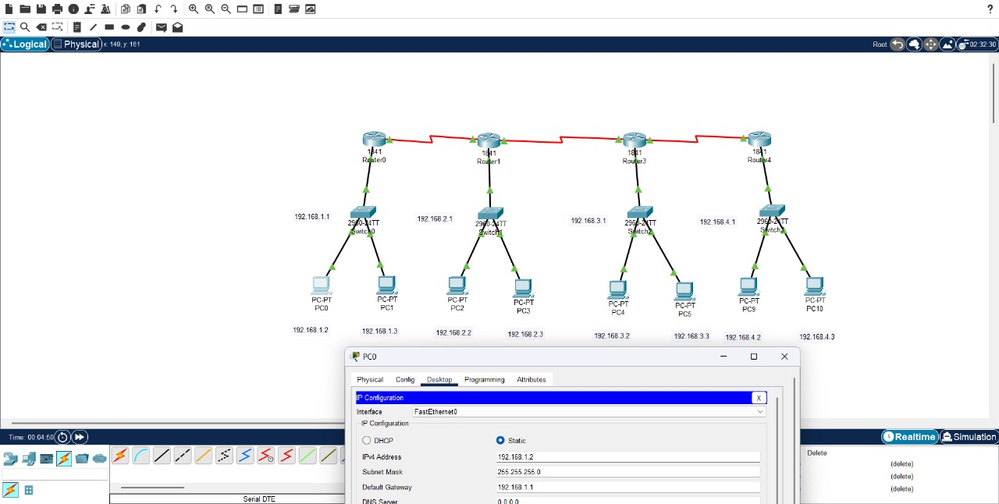
Figure 5.3: Assigning IP Address to PCs
Step 4: Adding serial ports to routers
Since Cisco 1841 routers do not come with built-in serial ports, WIC-2T modules were inserted. Each router was powered off, the module was added from the Physical tab, and then the router was powered on again to activate the serial interfaces.
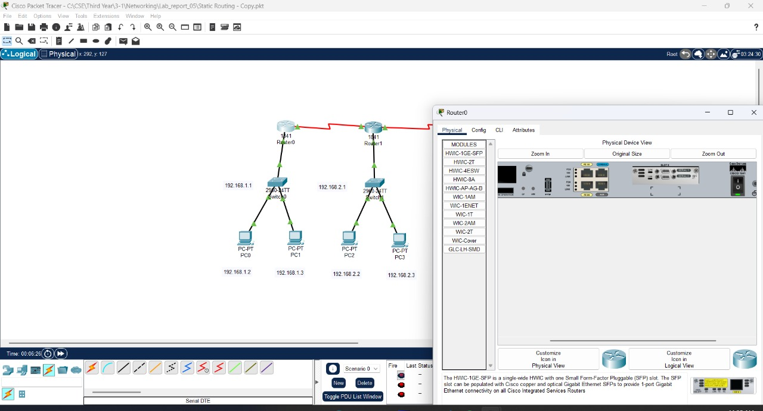
Figure 5.4: Adding Serial ports to routers
Step 5: Configuring router interfaces
The FastEthernet0/0 interface on each router was configured with its LAN gateway address, while the serial interfaces were assigned IPv4 addresses to form point-to-point links.
Configuring Router IPV4 Adresses:
- Router0:
  - FastEthernet0/0 → 192.168.1.1
  - Serial0/0 → 10.0.0.2
- Router1:
  - FastEthernet0/0 → 192.168.2.1
  - Serial0/0 → 10.0.0.3
  - Serial0/1 → 11.0.0.2
- Router3:
  - FastEthernet0/0 → 192.168.3.1
  - Serial0/0 → 11.0.0.3
  - Serial0/1 → 12.0.0.2
- Router4:
  - FastEthernet0/0 → 192.168.4.1
  - Serial0/0 → 12.0.0.3
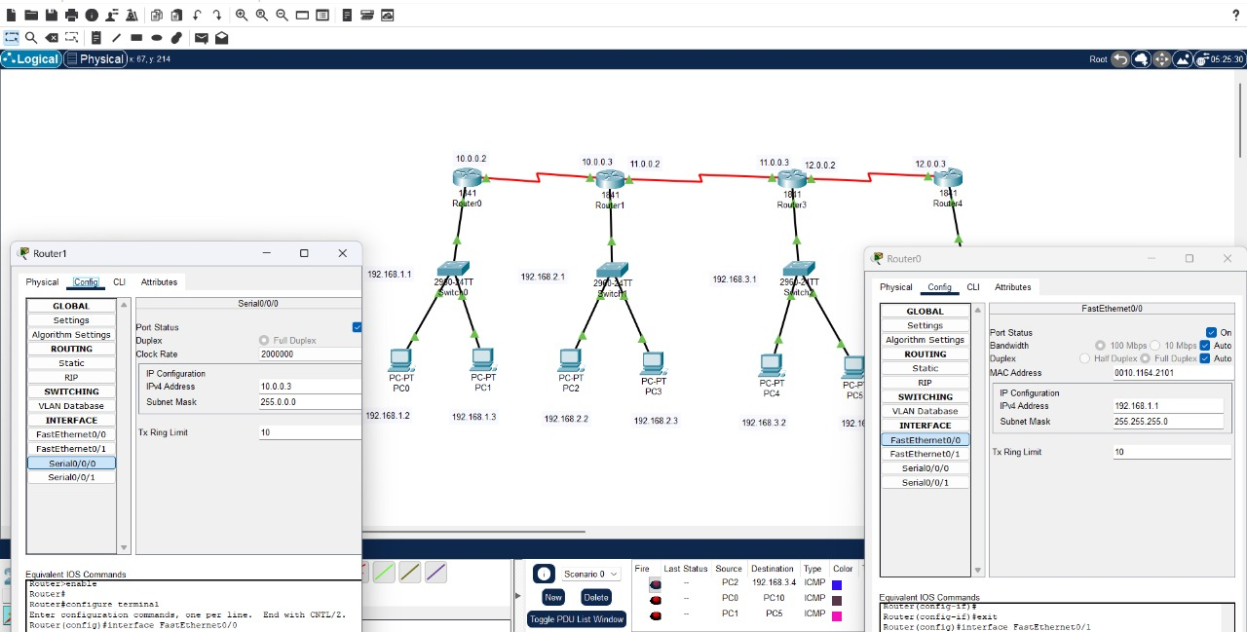
Figure 5.5: Configuring The Router Interfaces

Step 6: Configuring static routes on all routers
To achieve full network reachability, static routes were added to each router. Every router was instructed how to reach remote networks by specifying the destination network, subnet mask, and next-hop IP.
Static Route Configuration
Router0
- 192.168.2.0 → next hop 10.0.0.3
- 192.168.3.0 → next hop 10.0.0.3
- 192.168.4.0 → next hop 10.0.0.3
- 10.0.0.0 → next hop 10.0.0.3
- 11.0.0.0 → next hop 10.0.0.3
- 12.0.0.0 → next hop 10.0.0.3
Router1
- 192.168.1.0 → next hop 10.0.0.2
- 192.168.3.0 → next hop 11.0.0.3
- 192.168.4.0 → next hop 11.0.0.3
- 10.0.0.0 → next hop 10.0.0.2
- 11.0.0.0 → next hop 11.0.0.3
- 12.0.0.0 → next hop 11.0.0.3
Router3
- 192.168.1.0 → next hop 11.0.0.2
- 192.168.2.0 → next hop 11.0.0.2
- 192.168.4.0 → next hop 12.0.0.3
- 10.0.0.0 → next hop 11.0.0.2
- 11.0.0.0 → next hop 11.0.0.2
- 12.0.0.0 → next hop 12.0.0.3
Router4
- 192.168.1.0 → next hop 12.0.0.2
- 192.168.2.0 → next hop 12.0.0.2
- 192.168.3.0 → next hop 12.0.0.2
- 10.0.0.0 → next hop 12.0.0.2
- 11.0.0.0 → next hop 12.0.0.2
- 12.0.0.0 → next hop 12.0.0.2
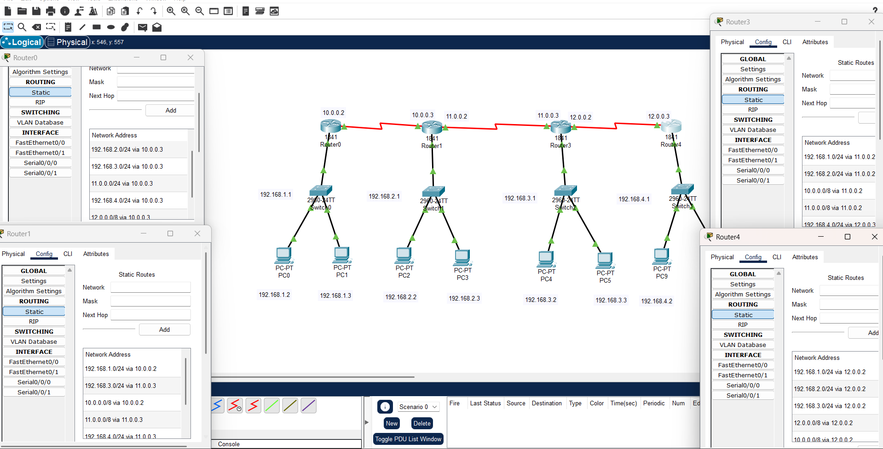
Figure 5.6: Configuring Static Routes on each Router
Step 7: Testing Connectivity
Simple PDU messages were sent between PCs. All tests displayed successful message delivery, showing that the static routes were set correctly and end-to-end connectivity was achieved.
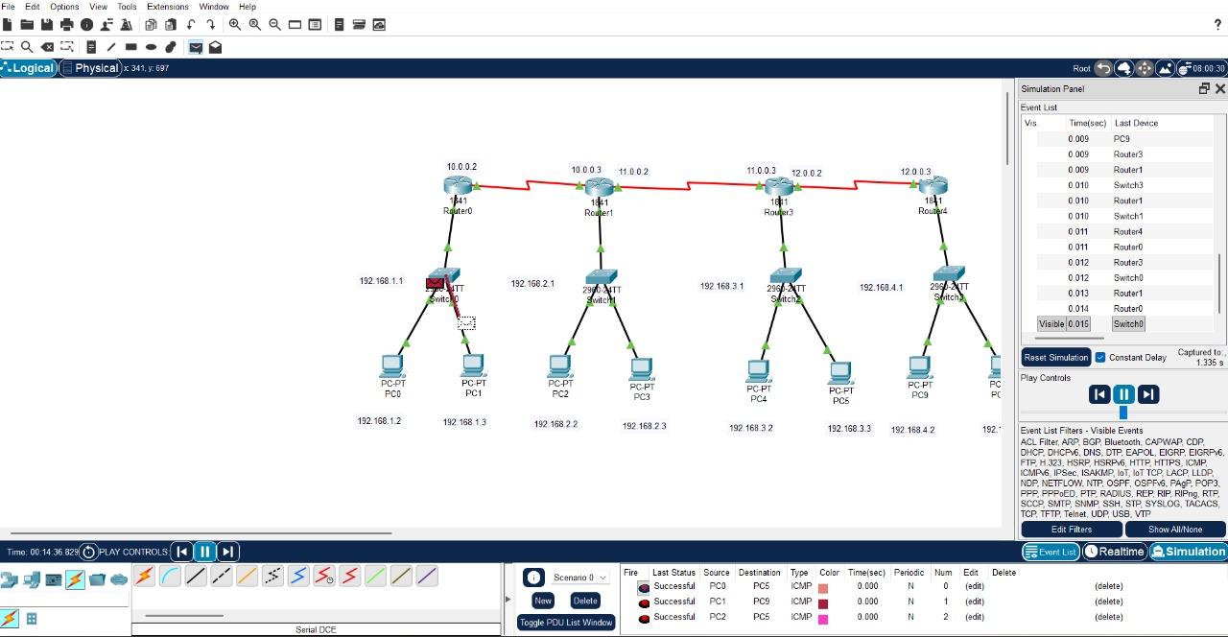
Figure 5.7: Testing The connectivity
Conclusion
This experiment demonstrated how static routing can be used to interconnect multiple LANs across several routers. By manually configuring IP addresses, interfaces, and routing entries, the routers were able to forward packets correctly through the entire path. The network behaved predictably and successfully allowed communication between all eight PCs. Static routing gives precise control over traffic flow and is an essential skill for understanding how routers operate in structured networks.

